Name : Sakthi Manoj R Reg No : 192324236
PROGRAM 14
Explore and Manipulate the ChickWeight Dataset
Aim:
To explore the ChickWeight dataset, sort records by weight, and calculate the average weight for each diet group.
Procedure:
Step 1: Open RStudio or the R console on your computer.
Step 2: Load the built-in ChickWeight dataset.
Step 3: Display the first few rows using the head() function to understand the dataset structure.
Step 4: Sort the dataset in ascending order by the weight column using the order() function.
Step 5: Print the sorted dataset to view the records arranged by weight.
Step 6: Use aggregate() to calculate the average weight of chicks for each Diet group.
Step 7: Display the average weight for each diet type.
Output :
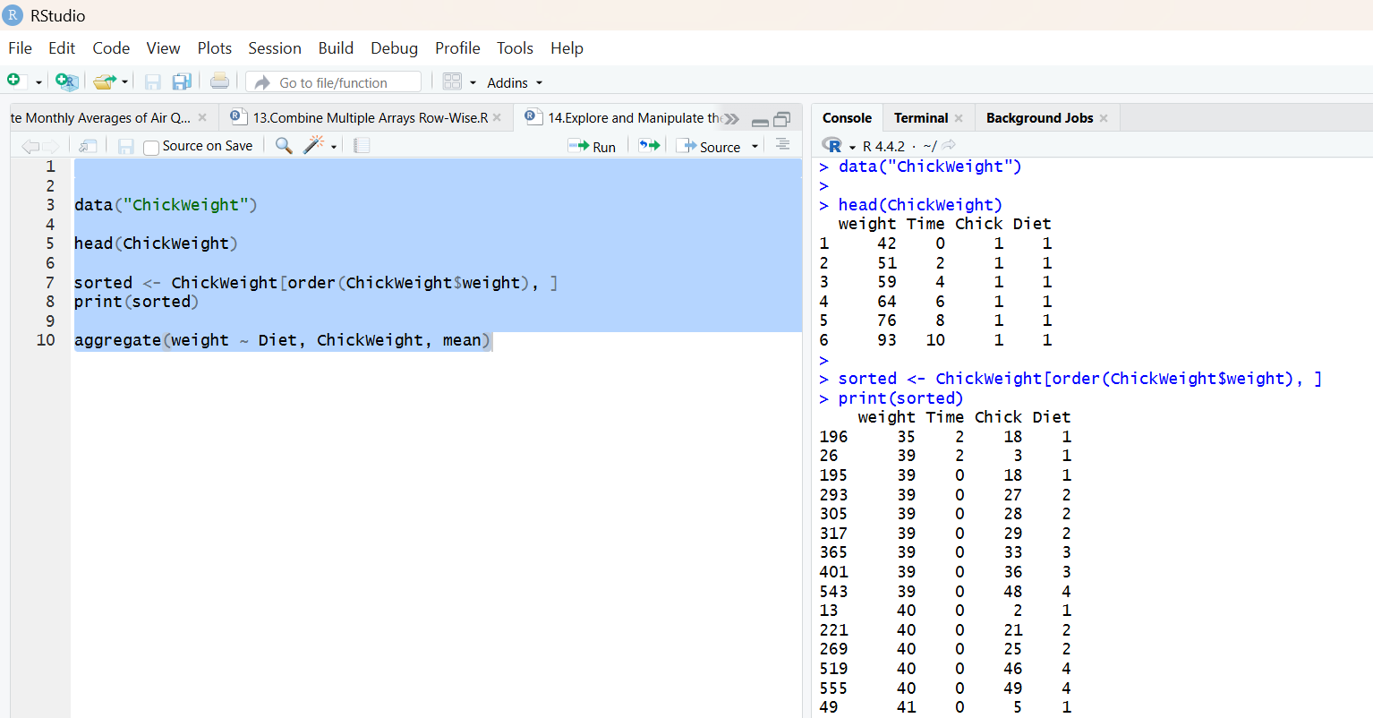
Result:
Hence the output is verified successfully.

